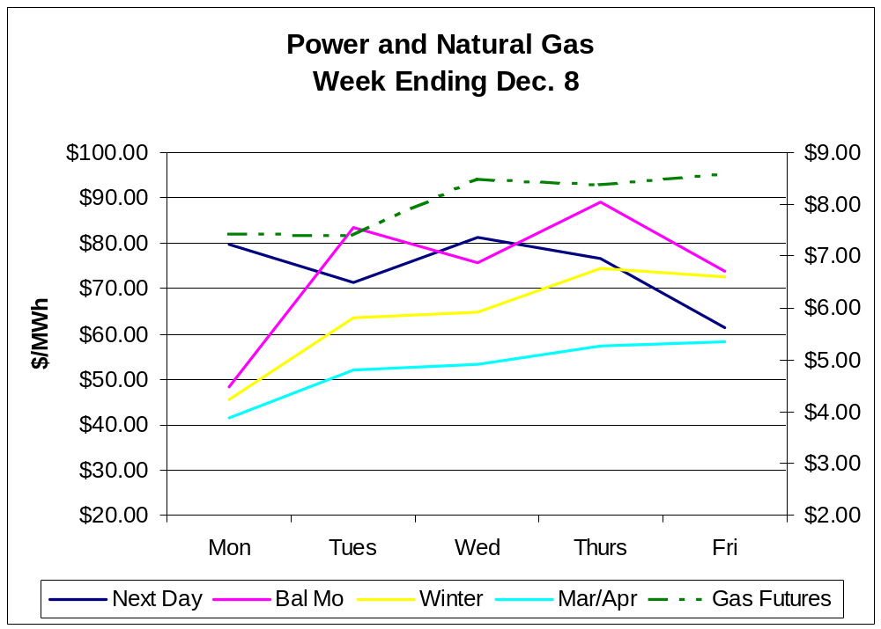

Sources: TNI power prices for Cinergy hub
Natural gas NYMEX futures prices for January delivery

